**shapeshifter**

***Misc***

**Challenge:**

There's this figure in front of me, but I can't even figure out what it is! What is that thing??

Attached - distant-figure.png

**Approach:**

We’re given a png file, but umm, it wasn’t opening? When I viewed it on hexed.it i noticed it did not contain the correct PNG headers, maybe it was a file of some other format? We use the file command to check the type of file it is:

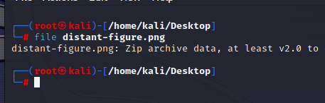

It’s a zip, so we’re gonna unzip

We see a true-form.exe in it but i don’t believe it, we use the file command again and notice its a RTF file:

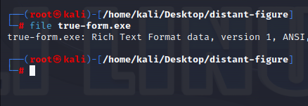

We use MS word to open it up and see the flag hidden in white font color:

**Flag: NICC{Y0U_F0UND_MY_TRU3_F0RM}**

Congrats!!

Happy Hacking!